**Task 6 , Date : 17/1/25**

1. Query a *count* of the number of cities in CITY having a *Population* larger than .

Input Format The CITY table is described as follows:

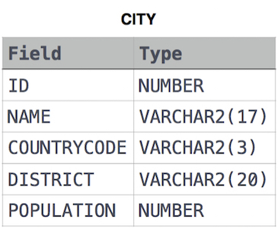

**Solution:**SELECT COUNT(ID) FROM CITY WHERE POPULATION > 100000;

1. Query the total population of all cities in **CITY** where *District* is **California**.

**Input Format.** The **CITY** table is described as follows:



**Solution:** SELECT SUM(POPULATION) FROM CITYWHERE DISTRICT = 'California';

1. Query the average population of all cities in **CITY** where *District* is **California**.

**Input Format.** The **CITY** table is described as follows:



**Solution:** SELECT AVG(POPULATION) FROM CITY WHERE DISTRICT = 'California';

1. Query the average population for all cities in CITY, rounded *down* to the nearest integer.

Input Format. The CITY table is described as follows:



**Solution:** SELECT ROUND(AVG(POPULATION))FROM CITY;